LGA Perceptions Survey 2017/18

Purpose of report
For direction.

Summary
This report provides members of the Leadership Board with a summary of the findings from the annual perceptions survey of our membership.
A hyperlink to the full detailed report will be circulated to members once it has been published. In the interim, a copy is available upon request.

Recommendations
That the LGA Leadership Board:
- notes the results of the 2017/10 perceptions survey
- agrees the draft action plan at Appendix A.
Action
As directed by Members

Contact officer: David Holdstock
Position: Director of Communications
Phone no: 020 7664 3056
Email: david.holdstock@local.gov.uk

LGA Perceptions Survey 2017/18
Background
- This is the sixth consecutive year we have undertaken a perceptions survey of our membership. This comprehensive, cross-cutting research provides us with a benchmark to inform future work and gives us a good understanding of the current views of member authorities. In addition, it helps us to better understand their views on the benefits of membership, their support needs, sector-led improvement, how well informed they feel about our work and areas for improvement.
- Last year, based on the previous year’s survey, members agreed an action plan to help support some of the key findings, in particular, work to help improve the overall awareness of the LGA, sector-led improvement and our work amongst frontline councillors.
- The group offices have continued to support our overall membership offer through their work with members and improvement teams have further developed our offer to include, as well as corporate support, bespoke support on issues such as finance, children’s services and communications.
- Our programme of visits to councils, at both senior political and managerial levels has supported our work to raise awareness of the work we undertake with and on behalf of councils. We have also continued to support councils with our work on legal collective actions.
- Last year we introduced new initiatives such as free places for frontline councillors at the LGA annual conference, allocated through the group offices and worked to encourage more input from them into first magazine, which remains the main way they receive information about the LGA and our work.
- Based on this year’s results, we have included an updated draft action plan at Appendix A.
Summary of results
Views on the LGA and its services
- Overall, the 2017/18 results are positive, and broadly consistent with last year. The results show that respondents have a high level of awareness of the LGA and the work we undertake on their behalf; there are high levels of advocacy (those who would speak positively about the LGA) and satisfaction with the work of the LGA remains high.
- Table 1 and Figure 1 below show how key results have changed since 2012. All of the categories in Table 1 have seen a significant increase since the first wave of the survey in 2012. Most notably, there has been a 19 percentage point increase in the proportion who think that sector-led improvement is the right approach in the current context, and a 16 percentage point increase in the proportion saying that the LGA demonstrates value for money.
Table 1: Summary of positive responses given for key measures
Question | 2012 | 2013 | 2014 | 2015 | 2016 | 2017 | Change from 2016
How well do you know the LGA? | 62% | 72% | 73% | 73% | 75% | 73% | -2
I would speak positively about the LGA | 63% | 73% | 72% | 74% | 74% | 73% | -1
Satisfied with the work of the LGA | 63% | 70% | 75% | 76% | 73% | 73% | 0
The LGA keeps you informed about its work | 69% | 78% | 79% | 84% | 83% | 80% | -3
Sector-led improvement is the right approach in the current context | 59% | 62% | 63% | 71% | 70% | 78% | +8
The LGA demonstrates value for money | 43% | 53% | 53% | 57% | N/A | 59% | +2*
*change from 2015

Figure 1: Summary of positive responses given for key measures
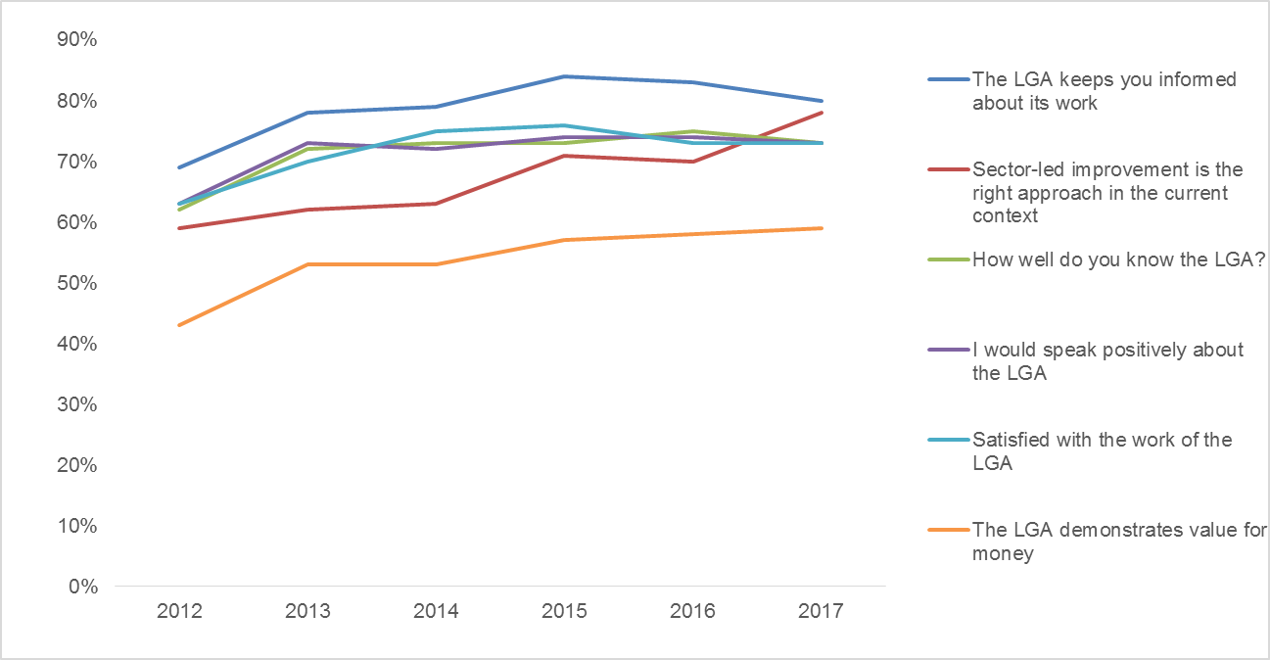
- Overall, seven in ten feel that they know the LGA well (73 per cent). This ranges from 96 per cent of chief executives and 94 per cent of leaders to 53 per cent of frontline councillors.
- Nearly three quarters of respondents (73 per cent) say that they would speak positively about the LGA to others. Just three per cent say they would speak negatively. Leaders (89 per cent) are the most likely group to speak positively about the LGA.
- Nearly three quarters (73 per cent) say they are either fairly or very satisfied with the work of the LGA. This is in keeping with results since 2013. Leaders proved the most satisfied group (88 per cent) compared to the lowest, frontline councillors (60 per cent).
- Despite a small reduction from 2016, the proportion of respondents who feel the LGA keeps them informed about its work remains high, at 80 per cent.
- There is an eight percentage point increase from last year in the proportion who think that a sector-led improvement approach is right in the current context (78 per cent).

- Three in five respondents agree that the LGA represents value for money (59 per cent). This varies substantially by type of respondent, with chief executives (78 per cent) and leaders (76 per cent) more inclined to agree, compared to frontline councillors (49 per cent) who are the least likely to.
Usefulness of activities
Table 2: Proportion who find activities useful
Question | 2012 | 2013 | 2014 | 2015 | 2016 | 2017 | Change from 2016
How useful are the following LGA activities to your council or local government as a whole?
Providing a single voice for local government | 90%* | 94%* | 91%* | 88% | 89% | 92% | +3
Providing up-to-date information about local government | 92% | 89% | 88% | 93% | 91% | 91% | 0
Lobbying on behalf of local government | 90% | 92% | 93% | 92% | 89% | 90% | +1
Managing local government’s reputation in the national media | 89%* | 93%* | 90%* | 83% | 83% | 82% | -1
Providing conferences and events | 71% | 79% | 77% | 85% | 83% | 79% | -4
Providing advice and information through the political group offices | 72% | 78% | 78% | 78% | 76% | 79% | +3
Negotiating national pay, terms and conditions and providing employment advice | 73% | 78% | 75% | 74% | 71% | 65% | -6
Providing legal advice and co-ordination of legal action for councils | 67% | 78% | 73% | 72% | 64% | 62% | -2
* Prior to 2015/16 respondents were asked whether or not these activities were important and are therefore not directly compatible.
- Providing a single voice for local government is the activity found most useful by respondents, at 92 per cent. Also scoring highly is providing up-to-date information about local government (91 per cent) and lobbying on behalf of local government (90 per cent).
- The results are mostly in line with 2016, although there are three changes to report: the proportion who say that providing a single voice for local government is useful has risen by three percentage points. Meanwhile, the proportion who say the activity of negotiating national pay, terms and conditions and providing employment advice is useful has fallen by six percentage points compared to 2016, while the proportion who say providing conferences and events is useful fell by four percentage points. Support
- Respondents were asked whether they thought the LGA should continue to provide support in a number of areas. Ongoing support from the LGA is valued in all of the areas outlined in the survey:
  - 93 per cent said the LGA should continue to provide practical support to help councils make efficiency savings, transform services and generate income;
  - 93 per cent said the LGA should continue to provide peer challenge and peer support (up from 90 per cent in 2016);
  - 91 per cent said the LGA should continue to provide training for councillors;
  - 87 per cent said the LGA should continue to provide support for developing a flexible and productive workforce, including training for officers;
  - 79 per cent said the LGA should continue to provide support for economic growth and devolution;
  - 75 per cent said the LGA should continue to provide support for increasing housing supply.
- When asked what new areas of support they would like to see provided by the LGA:
  - 70 per cent agreed that they would like to see support provided for emergency planning and resilience;
  - 62 per cent agreed that they would like to see specific support for children’s improvement.
Communications
- Four in five respondents (80 per cent) feel that the LGA keeps them informed about its work. Leaders (92 per cent), chief executives (88 per cent) and chairs of scrutiny (84 per cent) are the groups most likely to feel informed.
- Although there has been a reduction this year, ‘first’ magazine remains the most popular method of finding out about the work of the LGA (70 per cent, down six percentage points from 2016). It is particularly popular with senior councillors and frontline councillors (both 84 per cent). Meanwhile, officers are more likely to get LGA news from events and conferences (80 per cent), the LGA website (80 per cent) or media work/press releases (78 per cent).
- Responding to LGA consultations is the most popular form of engagement with the LGA (63 per cent). This was also the most popular in 2016, however the proportion selecting this option in 2016 was significantly higher, at 72 per cent. Around half of respondents indicated they engage by attending LGA events and conferences or through visits from LGA councillors and staff to their council (both 52 per cent).
Sector-led improvement
- There was an eight percentage point increase since 2016, in the proportion who said that a sector-led improvement approach is right in the current context (78 per cent). Directors (90 per cent), chief executives (88 per cent) and leaders (86 per cent) are strong drivers of this. Since 2012, there has been a 19 percentage point increase in the proportion saying that sector-led improvement is the right approach.
- Access to good practice to help authorities learn from others was seen as the most useful aspect of the LGA’s improvement support offer for councils (87 per cent), followed by peer challenges to provide an external view on performance (83 per cent) and training for councillors (79 per cent).
- Overall 87 per cent said that LGA improvement support has had a positive impact on their authority (an increase from 83 per cent in 2016). This increases to 95 per cent among chief executives and 96 per cent among leaders.
Differences by role
- As with previous years there are some variations by role. On the whole, chief executives, directors and leaders have a greater knowledge of and satisfaction with the LGA and more strongly positive views of sector-led Improvement compared to frontline councillors. The issue of engaging frontline councillors remains a challenge for us and continues to be addressed in our action plan for the year ahead.
Methodology
- A total of 1,004 interviews were undertaken with a sample of representatives from councils across all the English regions (including chief executives, directors, leaders, chairs of scrutiny, portfolio holders, frontline councillors, and, for the first time in 2017, leaders of the opposition).
- The majority of interviews were undertaken over the telephone, with six completed via Computer Aided Web Interview. This has given a strong, representative sample allowing detailed analysis by role and region. The sample size has a maximum standard error of ±3.0% at the 95% level of confidence, giving these findings a high level of accuracy.
- Prior to launching the survey a live pilot was conducted with 20 respondents to ensure the survey was fit for purpose and would last no longer than around 15 minutes. The survey explored:
  - overall views of the LGA;
  - its current role and offer and how these can be developed;
  - its communications and methods of engagement;
  - sector-led improvement within local government, the support offered by the LGA to assist its members in this and how this can be developed/improved.
Conclusions
- Overall, this year’s results are positive, and broadly consistent with last year. Respondents have a high level of awareness of the LGA and the work we undertake on their behalf, and satisfaction with the work of the LGA remains high.
- The issue of engaging frontline councillors remains a challenge for us and is addressed in our action plan for the year ahead.
- Our sector-led improvement offer remains well regarded, with an increase in the proportion who think that a sector-led improvement approach is right in the current context, and in the proportion saying that LGA improvement support has had a positive impact on their authority.
Financial Implications
- None.
Next steps
- As set out in the draft action plan at Appendix A.

Changes from previous years are only mentioned in the text if they are statistically significant.
Only respondents who said that they know at least a little about LGA took part in the survey. If a respondent said that they have never heard of LGA or had heard of LGA but knew nothing about it the survey was terminated. This is because a least a little knowledge of LGA is needed to be able to answer the later questions in the survey. In total 14 respondents said that they have heard of LGA but know nothing about it and one said that they have never heard of LGA.
Data have not been trended for ‘providing improvement support for councils’ due to changes in the way the activity has been asked about across the years, meaning that data are not directly comparable.

